**Parvaz Mohammad Sultan**

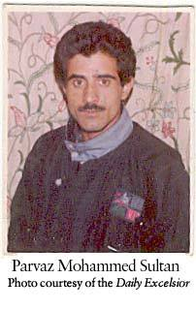

**About:**  Parvaz hailed from a remote village of Khiram in south Kashmir. A talented guy, he tried his hand in writing and soon carved a space for him in the vernacular press. He worked in Al Safa, and then a leading Urdu daily published from Srinagar and also wrote analytical pieces for Urdu weekly Chattan. Parvaz had also a stint as a reporter with Congress mouthpiece *Quami Awaz*, published from Delhi. However, in 2000 he launched his own news service to give fillip to feature writing and received an encouraging response from the readers and news organizations. He also edited a local newspaper *Wattan*, though unofficially

His 29-year-old wife Shameema was a broken soul who mustered courage to get a government job as compensation to her husband’s death. She needed the job to grapple with the challenge of bringing up three small children and ensure their education.

**Murdered on :** January 31, 2003.

**Attack details:** Two unidentified gunmen on Friday evening shot dead Parvaz Mohammed Sultan. The two gunmen came inside the office and were talking to Parvaz.

**Reason to him target:** The motive behind Parvaz’s killing continues to remain a mystery, as has been the case with hundreds of killings added to the accounts of “unidentified” gun men. Parvaz’s death was connected to the intergroup rivalry within a prominent militant organization.

**Occupation:** Editor of Urdu daily *Alsaffa News* and Reporter.

**Belief:** An encouraging response from the readers and news organizations.

**Link:**  <https://www.rediff.com/news/2003/jan/31jk2.htm>

<https://cpj.org/data/people/parvaz-mohammed-sultan/>

<https://ifex.org/journalist-killed-in-kashmir/>

